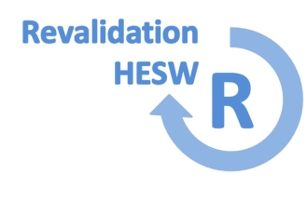

Revalidation

Wider scope of practice form
To be completed for any work undertaken outside of your training programme.
Surname: |  |  | Forename: |  |  |  | GMC Number:
Speciality Training Programme: |  |  |  |  | Deanery:

Part 1 – For the Trainee
Part 1 should be completed to declare any paid or voluntary work that you carry out outside of training in your capacity as a health professional. This could include working as an Off Site doctor e.g. in the Territorial Army, Air Ambulance, Racecourse etc., or any locum work, private practice, medico legal, charity work, Section 12 (Psychiatry), research etc. You should reflect on any work you do outside of training in your capacity as a health professional in your portfolio.
A separate form needs to be completed for each additional Scope of Practice.
Type of Work  (Locum/voluntary/Section 12/private practice etc.) | Start Date | End Date | Responsible Officer of Host Organisation (if applicable) | Name and Address of Employing/Hosting Organisation/GP Practice

Part 2 – For the Supervisor
Part 2 should be completed by the person supervising you in the role described above. If you do not have a medical supervisor for this role an Administrator/Manager can sign this form.
I confirm that I have no concerns about the fitness to practise of this trainee
If there is an unresolved concern or conduct, capability/ SUI investigation or a complaint for this trainee please download and complete an Exception Exit Report available from the Deanery website www.severndeanery.nhs.uk/revalidation and send it to severn.revalidation@southwest.hee.nhs.uk
Signature: |  | Date:
Name: |  | GMC Number:
Job Title: |  | Organisation
Email: |  | Telephone:

