Health Education England SW Simulation Network

Simulation and TEL Project Application Form 2021

Introduction

Health Education South West Simulation Network (HEESWSN) has been allocated funding for projects which will seek to develop multi-disciplinary education through the use of innovative educational technologies across the South West region. Such projects will usually be based around simulation-based education, but might also include e-learning programmes, virtual reality technologies and others.

Funding will usually be in the form of Fellowships for one year, but other projects will also be considered subject to the scoring criteria. Where projects propose to appoint simulation technical staff, priority will be given to projects that utilise Apprenticeship schemes, and which will deliver training pathways in line with the RSCiTech qualification (https://sciencecouncil.org/scientists-science-technicians/which-professional-award-is-right-for-me/rscitech/).
The projects must support the development and delivery of multi-professional educational projects and initiatives throughout the South West region within NHS providers, HEIs, social care or other healthcare settings. Any resources developed through these projects must be shared with other NHS providers, for instance using the iRIS platform. All proposed projects must align with at least one of the 5 Simulation Network
- Multi-agency Simulation Activity
- Simulation Technicians
- Research
- Virtual Simulation, Digital Technologies and Innovation
- Standardised Patients.

Project leads must be supported by an executive sponsor from their host organisation and will be expected to submit quarterly reports to HEESWSN. HEESWSN will support the project team with a dedicated mentor drawn from the Network, and the team will be encouraged to share their progress with the other successful project teams at Network meetings.

Project funding will incorporate funds to execute the project (such as a salary for the Fellowship position) and other costs that are deemed necessary. Purchase of simulation equipment will be not usually be funded, but applicants are welcome to incorporate requests for specific items of equipment within the overall bid.

HEESWSN will convene a Simulation Project Selection Committee who will be representative of the Network and will include members from a diverse range of backgrounds. The committee will be tasked with assessing bid applications and the final group of successful bids will be selected based on merit.

Division and management of the funds

The intention is to spend the funding supporting Trusts, NHS providers and other healthcare organisations in establishing educational projects with demonstrable human factors, patient safety and quality improvement benefits for multi-professional workers within their organisation and across the SW region, or supporting development of a safe and capable workforce, preventing ill health and supporting healthier lives. Furthermore, HEESW proposes that organisations explore the sustainability of these posts with the intention of permanently funding the role after the 12 month funded post ends.

Simulation Fellowship roles may be drawn from medicine, nursing or other healthcare professional backgrounds. Technician posts funded as part of this funding stream should be open to all eligible applicants and should be linked to Trust Apprenticeship Schemes where possible. Technician posts do not normally have to be filled by individuals with a clinical background, but the range of technician roles is wide and all suggested posts will be considered. Funding will be available for a maximum of £30,000 per project. Priority will be given to projects that target groups or organisations that have limited access to simulation-based education or other TEL interventions.

Criteria and contractual obligations for bids

Bidding organisations are obliged to provide suitable professional continuing support for a fellow, technician or other staff member employed as part of the project. It is imperative that there is time set aside that enables the fellow/technician to convene at least weekly with a project lead or mentor from their organisation. They should also be provided with appropriate resources to support the project – information and a proposed outline about these must be detailed in the bid.

HEESWSN will provide a named member of the Network who will be the liaison between the Network and each project, and who will provide external mentoring and guidance as well as receiving project reports and updates, as detailed below. We would anticipate that the Network Liaison would have contact with the fellow/technician and project lead on a monthly basis, with quarterly face-to-face meetings, and agreement to this is a fundamental requirement in order to receive funding.

The bid must include a detailed section describing how the fellow/technician and/or the project they undertake will improve the quality of patient services and enhance patient safety, and how this will be shared across the South West region through HEESWSN. All projects will be expected to develop multi-professional and multidisciplinary groups in their work, ensuring full inclusion of medics, nursing, AHPs and other organisation employees.

Full co-operation and participation is required from all organisations, fellows/technicians and mentors with the use of iRIS (www.irishealthsim.com). This is a web platform to developing, collaborating and sharing of simulation and education resources. All healthcare workers engaged in SBE in the South West region can have access to the system and this will be arranged for all successful applicants if they do not already have access. All scenarios and learning materials developed must be uploaded to the iRIS system for collective use where appropriate.

Whilst all fellows/technicians, project leads and other staff appointed through this funding stream will be employees of the bidding organisation and not of HEESW, it is a prerequisite of the bid that good communication is fostered and maintained with the Simulation Network and the Associate Deans for Simulation.

A detailed quarterly update is required from each project. This is essential to ensure a regular review with risks and issues at the end of each quarter is reported to HEESW via the Network Liaison. An end of project form detailing outcomes and benefits must be completed to demonstrate for value for investment.

Meetings of the HEESWSN will be held quarterly throughout the year, and attendance at these meetings is mandatory. Additional meetings will be organised to support development of the fellows/technicians and project leads within their roles, provide a forum for sharing practice and activity and offer educational development. Projects also undertake to present their project at the annual South West Simulation Network Conference, held in October of each year (next due to be held in October 2022).

A project lead and executive sponsor is a precondition for each bid. Assurances will be required from these individuals that the project has full support from the organisation and all parties involved from each division that the project crosses.

Finally, projects must be novel and not previously funded through the HEESWSN – the funding is strictly for one year only and will not be recurring.

Guidance on completion of the application form:
- Applications should clearly outline the planned Human Factors, Patient Safety and Quality Improvement objectives to be addressed through a simulation-based or other TEL educational intervention.
- Priority will be given to projects which include strategies to train disciplines or groups that do not currently have access to this type of training or are based in organisations without established access to this type of training.
- Priority will be given to projects which support clinical placements in health and social care organisations.
- Priority will be given to projects that take a multi-disciplinary approach to training.
- Priority will be given to projects that incorporate innovative technologies or other educational methods.
- Priority will be given to projects that will prevent ill health and support healthier lives.
- Priority will be given to projects that will enhance healthcare resources across the South West region.
- Priority will be given to projects that involve partnerships between organisations and between the NHS and private enterprise.

Identified professional background of fellow/technician, project lead and other proposed project staff
- Applications should clearly state the professional background of all staff who are to be involved in the project, or the proposed background of staff that are planned to be recruited. In situations where the fellow/technician has already been identified their details should be included in the application. In most situations it would be expected that the project lead will provide mentorship to the fellow/technician, but if this is not the case then proposals for how the fellow/technician will be mentored should be included. Applications where mentoring arrangements for the fellow/technician have already been identified will be favourably reviewed.

Organisational resources to support fellowship
- The bidding organisation should outline the resources available to support the project in terms of infrastructure, support staff including mentoring systems and access to equipment to implement the project. In situations where resources are not yet in place applications should be accompanied with a business plan outlining organisational funds identified and steps being taking to ensure resources will be in place.

Support from the Organisation leadership
- Applications should identify how the objectives of the project align with the strategic intent of the organisation. In addition, written support from leadership (an executive sponsor) of the bidding organisation must accompany the application along with information about how the post will be professionally supported.

Level/grade of Fellow (eligibility for Simulation Fellowships)
- Positions will be open to all health and care professionals across the Southwest. Please state clearly in the bid application the staff group, grade and/or level of the proposed Fellow. In cases where an organisation’s application for funding has identified the professional background of the proposed Simulation Fellow to be medical, only postgraduate trainees of the level ST4 and above will be considered. Where the organisation has proposed a Fellow from another professional background they must hold a band 6 post or above during the fellowship. SAS and non-training grade medical Fellows should be ST4 equivalent or higher. An exception may be made in situations where the proposal is to employ a simulation technician at a lower band than Band 6, but in this case it would be expected that the technician would not be the Project Lead. Where funding is not sufficient to employ the fellow on a full-time basis, there should be a plan for employing them in a less than full time capacity and making up their hours with clinical work or through other means.

Scoring of applications

Applications will be assessed with a score of 1-5 on each of the following criteria:
- Detailed description of objectives and scope of the proposed project
- Potential contribution of project to improve patient safety and outcome
- Potential for the project to increase opportunities for clinical placements in health and care settings
- Clear commitment to the multiprofessional nature of the project and its goals
- Information about how the project/intervention links with Trust and HEESWSN objectives/workstreams
- Potential for benefits to the wider healthcare network across the South West
- Comprehensive description of implementation methodology and timeline of the initiative
- Detailed information about the level of support and resources that will be in place in the organisation to ensure success of the project
- Details of the named mentor for the simulation fellow/technician, including their experience in simulation, human factors, quality improvement and patient safety activities
- Clear and detailed description of how monthly progress reviews will be carried out
- Evidence of support from leadership of proposed clinical implementation area (detailed letter of support to be included)
- Clear plans for the evaluation of impact identified
- Thorough plan for disseminating the results from the project described in detail

Application process

Proposals for consideration (including this form and supporting documents) should be sent by email to PenADAdmin.SW@hee.nhs.uk by 12 noon on Friday 30th July 2021. Scoring and evaluation will be completed during August and shortlisted applicants will be notified as soon as possible. Successful projects will receive their funding from HEE in before the end of 2021. Projects should be able to commence before the end of the 2021-22 financial year.

Proposals must be submitted using the pro-forma in this document and will be assessed using the criteria listed above. The decision to shortlist a project proposal will be based upon the quality and relevance of the submitted information on this form. Please complete HEE South West Project Initiation Document (page 5-8 Brief PID value less than £10,000 or Full PID for greater than £10,000, pages 5-15). HEESW PID must also be completed, and will form the basis of ongoing project management through HEESWSN if the project is successfully funded (PID Part 2 pages 12-14). In addition, please complete the additional application questions on page 15.

Requests for further information and any queries about the application process should be directed to the Associate Deans for Simulation – Wai-Yee Tse and Dan Freshwater-Turner (wai-yee.tse@nhs.net or dan.freshwater-turner@uhbw.nhs.uk)
Please complete the HEE South West Project Initiation Document and additional application questions (please note that the additional application questions should be completed for both Brief or Full PIDS) below:

Health Education England South West Simulation Network Project Proposal Form 2021-22
HEE South West Project Initiation Document
PART 1 – Initiation and Review - To be completed for Review (And then updated during Project Delivery as necessary)
(Please refer to guidance document to aid completion)

Section 1 – Summary
Funding Year: |  |  | 2021-22 |  | Project Title: |  |  | Standardised Patients in Prison Training
Funding Required from HEE: |  |  |  |  | Organisation to receive funds: |  |  |  |  | Hanham Secure Health
Total project value: | £10,000 |  |  |  | Other Funding Bodies: |  |  |  |  |  |  | Value:
NHS Priority: | Prevention |  |  |  | Main staff group impacted: |  |  |  | Clinical Support Staff (including Healthcare Assistants) |  |  | Primary aim: |  |  | Improve population health outcomes
Start Date: | 01/09/2021 |  |  |  | End Date: |  |  |  | 31/08/2022 |  |  | Revised End Date: |  |  | Select date
Project Manager - Name and Title: |  |  |  |  | Abi Bartlett |  |  |  |  | Email Address: |  |  | Abi.Bartlett@nhs.net
Project Manager - Organisation: |  |  |  |  | Ash Hodge |  |  |  |  | Contact Number:
Provide a short summary for the use of these funds including the output: |  |  |  |  | This project is to devise an accredited training for peer mentors residents in the prison and staff within our services to become standardised patients. This will enable us to deliver SIM training which is real and informed by lived experience.  The project will allow learners to react and respond to a full range of patient types, learning that factors such as gender, age, religion etc. may impact how a patient presents and behaves and that it is necessary for the learner to adapt their approach to meet the needs of the individual, thereby ensuring that services are inclusive.  Output:  - An opportunity for people living in prison to develop a skill which could be used on release.  - An accredited training programme for standardised patients in prison  - A programme of SIM which is informed by lived experience
Geographical Area Covered: |  |  | ☒ HEE Region: South West  ☐ ICS: Please Select ☐ Training Hub: Please Select ☐ Other…please overwrite…
HEE Star: |  | New Ways of Working |  | COVID-19 Related: |  |  | No |  |  |  | People Plan: |  |  | 5. Growing and Training our Future Workforce
For ICS projects: Is this project aligned to all ICS Diversity and Inclusion Plans? |  |  |  |  |  |  |  |  |  |  |  |  | Please Select
Please provide, if appropriate, a short summary: |  |  |  |  |  | N/A
For HEE projects: Is this project aligned to the HEE SW Diversity, Inclusion, & Participation Business Plan? |  |  |  |  |  |  |  |  |  |  |  |  | Yes
Please provide, if appropriate, a short summary: |  |  |  |  |  | The project will support our ability to deliver training that meets the needs of all learners, by offering more ‘real life’ situations to which staff can be supported to react and respond according to their abilities, competencies and individual learning needs.  The project will allow learners to react and respond to a full range of patient types, learning that factors such as gender, age, religion etc. may impact how a patient presents and behaves and that it is necessary for the learner to adapt their approach to meet the needs of the individual, thereby ensuring that services are inclusive.  Multi agency working will factor in the training, thereby expanding the breadth of participation. This will include the development of ‘lived experience’ peer mentors from the Hepatitis C Trust, along with a representative group of HSH employees to play the role of ‘standardised patient’ in order to:  - Be able to run SIM training regarding Hep C testing and management  - Be able to run SIM training regarding substance misuse and the effect on oral health.  The aim will be to have this training accredited once written via CPDUK
Does this project contribute to widening participation in the healthcare workforce? |  |  |  |  |  |  |  |  |  |  |  |  | Yes
Please provide a short description: |  |  |  |  |  | This project will involve a variety of agencies who participate in the healthcare of people living in prison, including the people living there themselves. Agencies include: prison, dentistry and the Hepatitis C Trust  The overall outcome of the project is to improve population health by:  1.Increasing the take up of screening for Hepatitis C  2.Promoting responsibility and self-management of long-term medication  3.Reduction of wasted amber list medications  4.Structured communication with community healthcare providers on release  5.Structured communication with receiving prison on transfer from our own prisons  6.Promotion of making every contact count (MECC) with wider health promotion especially with regards to oral hygiene and the effects of substance misuse  7. Developing a role for those service users who take part who perhaps can take it with them on release to support other community action groups.
Is Expert by Experience (EBE) included within this project? |  |  |  |  |  |  |  |  |  |  |  |  | Yes
If yes, how? If not, please explain why? |  |  |  |  |  | This will involve the Hepatitis Trust peer mentors who are people either currently living in prison with lived experience of hepatitis C, or people who have previously been in prison with experience of Hepatitis C

PID Completed By:  (Name, Email, Job Title & Organisation) | Abi Bartlett | Date: | 16/07/2021

HEE SW PPMO Internal use only:
Date Received by HEE PPMO: | Select date | HEE REF number:
HEE SRO/PL/SRM/THB&DM: |  |  | HEE Programme/Priority/Theme:
Date Reviewed by HEE: | Select date |  | Review Outcome |  | Please Select

Section 2 – Briefly outline why this funding is required?
Background / Need: | Hanham Secure Health (HSH) has a commitment to SIM as a mode of learning and is a member of the South West SIM Network.  A high proportion of people in prison have a history of substance misuse. The physical healthcare service, that HSH delivers within five South West prisons, has the opportunity to have conversations with patients about wider aspects of their health when seen for a scheduled appointment, in line with Making Every Contact Count (MECC) - Making Every Contact Count (nice.org.uk). Oral health and the impact of substance misuse is one area where the service could have a widening, holistic discussion and where significant education and improvement of health within the prison population could be achieved.  There is a national commitment to eliminate hepatitis C within UK prisons. In order to achieve this, we need to ensure our screening processes and conversations with patients are focused and patient centred.  Through the robust reporting and review of clinical incidents, we have identified communication with patients regarding their medication could be improved, specifically in situations where a patient leaves the prison or is transferred to another prison before their treatment is completed. This would enable patients to be involved in and take responsibility for their health, in line with NICE Shared decision-making guidance Shared decision making | NICE guidelines | NICE guidance | Our programmes | What we do | About | NICE  Developing standardised patients within the service and utilising them in SIM training would enable our team to further develop and improve their practice in relation to the varying and unique needs of individual patients.
Rationale: | Developing people with lived experience to influence the development of a standardised patient will ensure the patient profile will be real and relevant.
Scope (including benefits to the wider healthcare network across the South West) | The scope of this project will cover five prisons in the South West which are made up of both male and female service users, aged 18+, with about 500 personnel (include prison officers, prison staff and healthcare staff) in each site.
Alignment to other strategies (including Information about how the project aligns with Trust and HEESWSN objectives (including the five HEESWSN workstreams): | This application aligns well with the core values of Hanham Secure Health: Collaborate, Make a Difference, Improve, Have Integrity and Put People First. It also aligns with our Business Strategy and strategic objectives to:  - Be a leading healthcare provider within the secure estate  - Be seen as a preferred provider and be invited to bid for new services  - Achieve excellence in the quality and provision of our healthcare services  - Affect change within the secure healthcare setting, on both a local and national scale  - Have a fully embedded and celebrated culture of shared and supported learning  - Be an employer of choice  - Have greater opportunities available to the organisation, our employees and our patients  It also aligns with the HEESWSN workstreams of:  - Multi Agency Working – HSH would be working with the HepC Trust, Prisons, possible exploration with Community Links/Agencies and services that might accredit the training.  - Research – HSH have identified project outcomes with this proposal which might be reported against  - Standardised Patients – this is the move towards behaviours, communication and interaction with people. It is well known in the secure setting that it is easier to say “No” to everything especially on first arrival when you are alone and scared as you pass through Reception  The application also aligns with This is underpinned by our commitment to the three core, shared objectives set out in the National Partnership Agreement for Prison Healthcare in England (2018-2021), to:  - Improve the health and wellbeing of people in prison and reduce health inequalities.  - Reduce re-offending and support rehabilitation by addressing health-related drivers of offending behaviour  - Support access to and continuity of care through the prison estate, pre-custody and post-custody into the community

For PIDS with a Total Value less than £10,000 please now complete Section 3.
For PIDS with a Total Value greater than £10,000 please now complete Sections 4-8

Section 3 – ** Only Complete for PIDs with a Total Value of less than £10,000 **
High Level Costings Breakdown: | Milestones |  | Anticipated Cost
 | Design of standardised patient in the prison |  | £3,800
 | Delivery of training of standardised patient in the 5 prisons |  | £4,200
 | Project management |  | £1,000
 | Equipment, resources and facilities |  | £500
 | TOTAL: |  | £9500
What will be measured or evidenced to demonstrate impact of this investment? |  | - Project report to be submitted quarterly  - Take up of screening for Hepatitis C this can be measured through HJIP data.  - Reduction of wasted amber list medications, which are very expensive  - Review of incidents, anticipated reduction of incidents regarding Hep C medication especially with service users on transfer or release by those who have been involved with the programme assert their requirements to go through reception before leaving the site as they know they have medication to collect before they leave. The phrase that is often reported “Is that you don’t need to go through Reception you can now just go”.  - Testing data
How will this project be evaluated to understand the benefits realised from the investment? |  | - Pre and post survey of staff and peer mentors regarding patient engagement following the delivery of the project  - Review of clinical record  - SIM with standardised patients delivered as a routine  - Training for standardised patients in prison written and CPD accredited

End of Part 1 (Brief PID)

Section 4 – How and what will be measured to demonstrate benefit / impact?

Please outline what SMART measures / KPIs you will use to monitor and assess the impact of this investment. (add additional rows if needed).
Provide Information for PID to be approved: |  |  | Provide Initial Information – then refine during Delivery of Project:
Ref | Beneficiary(s)  (Who will benefit from this project) | Benefit Type  (How will people benefit from this project) | Benefit Classification | When do you expect to realise this benefit? | How will the anticipated benefit be measured? | What is the baseline for comparison? | What is the projected outcome / target?
1 |  |  | Please Select | Please Select
2 |  |  | Please Select | Please Select
3 |  |  | Please Select | Please Select
4 |  |  | Please Select | Please Select

Section 5 – If the project will deliver Training Modules (upskilling), please complete the table below:
Course / Module Title | Training Provider | Accreditation Status | Start Date | End Date | Total Cost | Number Plan | Number Completed
 |  | Choose an item. | Select date | Select date | £
 |  | Choose an item. | Select date | Select date | £

Section 6 – What is the Plan to deliver this funding (milestones)?
Please list the milestones you plan to deliver with timescales and anticipated costs.
Please also note that evaluation is a mandatory final milestone.
PLAN |  |  |  |  | ACTUAL
Milestones |  | Start Date | End Date | Anticipated Cost (£) | Expenditure (£) | Diff (£) | Forecast (£) | Status
 |  | Select date | Select date | £ | £ | £ | £ | Not yet started
 |  | Select date | Select date | £ | £ | £ | £ | Not yet started
 |  | Select date | Select date | £ | £ | £ | £ | Not yet started
 |  | Select date | Select date | £ | £ | £ | £ | Not yet started
 |  |  |  | £ | £ | £ | £

Section 7 - Project Evaluation – Dissemination – Sustainability
Description of how monthly progress review will be carried out
Provide a summary of the evaluation methodology that will be used to evaluate this project:
Will evaluation be internal or external?  (If over 100K, external evaluation required) | Please Select | Name of external organisation conducting the evaluation:
Please provide details of how you will measure the impact:
How will the findings/successes/lessons learned from this project be shared?
How will the learning from this project / investment be continued over-time?
(i.e. sustainable / business as usual / mainstream)

Section 8 – What are the identified Risks to the delivery of the milestones (section 6), and the potential disbenefits from this project / investment succeeding and how will these be mitigated?
Definition: A risk is an event that has not yet occurred but will negatively impact delivery of the investment objectives.
Ref | Risk Description | Date Identified | Severity | Likelihood | Total risk score  Severity x likelihood | Mitigating action | Risk Status
 |  |  | 1 (low) – 5 (high)
1 |  | Select Date | Select Score | Select Score |  |  | Please select
2 |  | Select Date | Select Score | Select Score |  |  | Please select
3 |  | Select Date | Select Score | Select Score |  |  | Please select

End of Part 1 (Full PID for larger investments)
PART 2 – Delivery - To be updated quarterly after PID Approval (During Project Delivery)

Section 9 – Progress against the Project Plan
Please provide the spend (£) for this quarter and assign a confidence delivery status. Where ‘Off track’ or ‘Off track – intervention required’ is selected, an action plan must be provided to improve progress and ensure delivery of this investment
Period Covered: | Please select |  | Spend to date: |  | £ | Confidence Delivery Status: |  |  |  |  |  | Please select
Please review the following sections and tick when completed: |  |  | Section 4 – Benefits ☐ |  | Section 5 – Upskilling ☐ |  |  | Section 6 – Plan ☐ |  | Section 7 – Evaluation ☐ |  |  | Section 8 – Risk ☐
Progress Update:
- What have you achieved in this period?
- What has gone well / not well?
- What is the impact?
- What are you looking to achieve next period?
If ‘Off track’ Amber or Red, what SMART actions are required to improve progress and ensure delivery of this investment?  Please note that this MUST be completed if the project status is Red or Amber. |  |  |  |  |  |  |  |  | Target Date |  | Select date
Name of Person Completing Update: |  |  |  | Role of Person Completing Update: |  |  |  |  | Completion Date |  | Select date

PART 3 – Evaluation - To be completed after the Project Deliverables have been achieved.

Section 10 – Evaluation Evidence Checklist
Please tick to confirm each of the following has been completed and provide the date it was submitted to HEE SW PPMO along with the Name of the document which includes each section.
 | Complete | Sent to PPMO | Document Name / Link
Has evidence of the evaluation including methodology, who completed, and data gathered been documented? | ☐ | Select date
Has work been completed to map the impacts of this project to anticipated and achieved benefits? | ☐ | Select date
Has work been completed to detail how this change will now be incorporated into Business as Usual? | ☐ | Select date

HEE SW PPMO Internal use only:
Date Evidence Received by HEE PPMO: | Select date | Evidence location(s):
Date Project Closed: | Select date | Closed by:

Change Control Record

Change Control (add additional rows as required)
Section | What has been changed? | Date of change | Change  made by | HEE Project Lead Approval  (Date Approved)
 |  | Select date
 |  | Select date
 |  | Select date
 |  | Select date
 |  | Select date
 |  | Select date
 |  | Select date
 |  | Select date
 |  | Select date

Additional Application Questions:
Description of implementation methodology and timeline of the project | The project will be implemented in accordance with the Organisation’s Project Management policy and procedure. Our standard process for project delivery illustrated below:  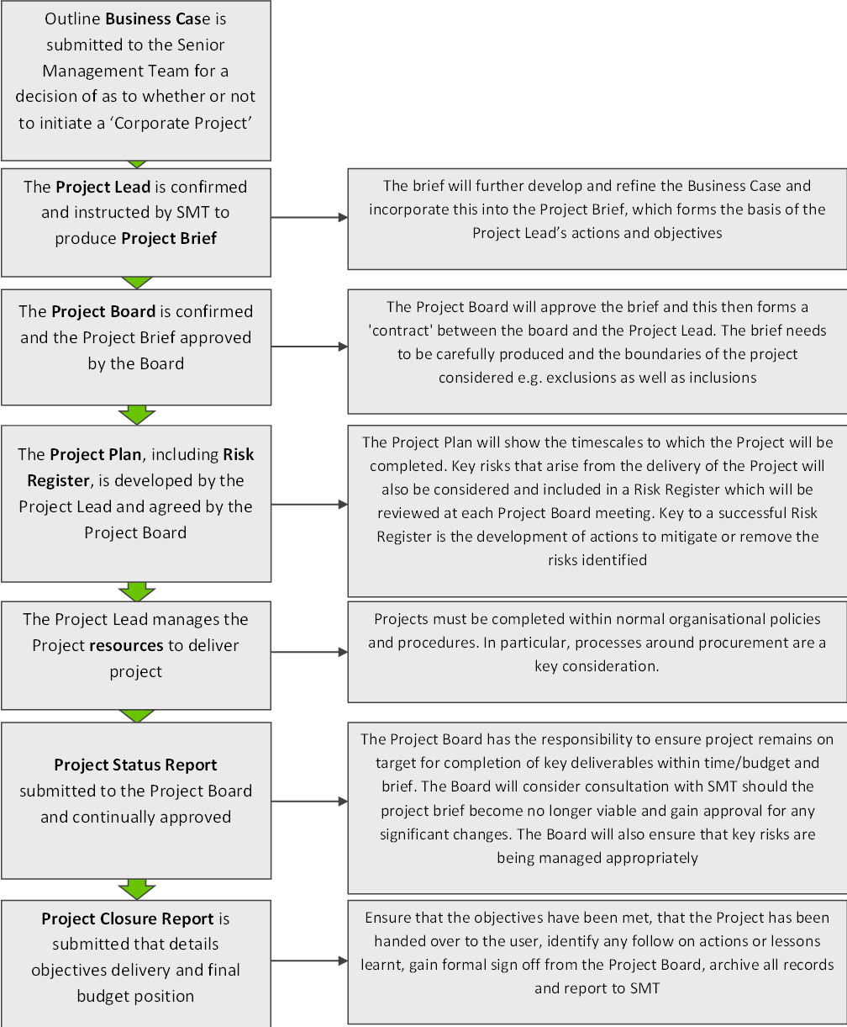  Specifically for this project, the team will:  Step Timeframe  - Establish goals for the training program – training needs analysis This project to run over 12 months from funding  - Build training plan Q1 - Q2  - Create training content / procure training resources Q2 - Q3  - Train the trainers Q3  - Deliver the training (trial) Q3 - Q4  - Review and improve – cultivate the content Q4  - Apply for CPD accreditation Post project/Q4  - Business as usual
Organisational resources to support project (Consider – mentoring arrangements, equipment, place of work, access to work computer) | a. Dedicated project lead  b. Room for training/running the SIM  c. Computer  d. Relevant clinical equipment to replicate real life scenarios  e. Actor to support writing of standardised patients
Brief outline of the support from the Organisation’s leadership and from the leadership of the proposed clinical implementation area (should include a letter of support from an Executive Sponsor) | The Organisation is built upon three key pillars:  - Business and Development: concerned with the day-to-day running of the business, financial management, contract management, legal and commercial matters, marketing and communications, digital systems and operational leadership.  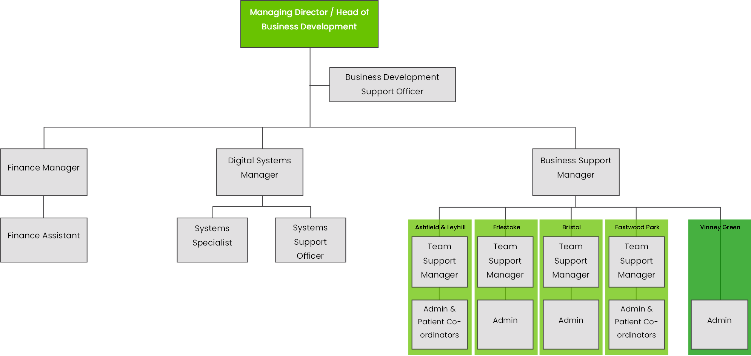  - Clinical Services: concerned with the delivery of the Organisation’s core function, clinical service delivery. This includes quality assurance, risk management, clinical leadership, service improvement and clinical care.  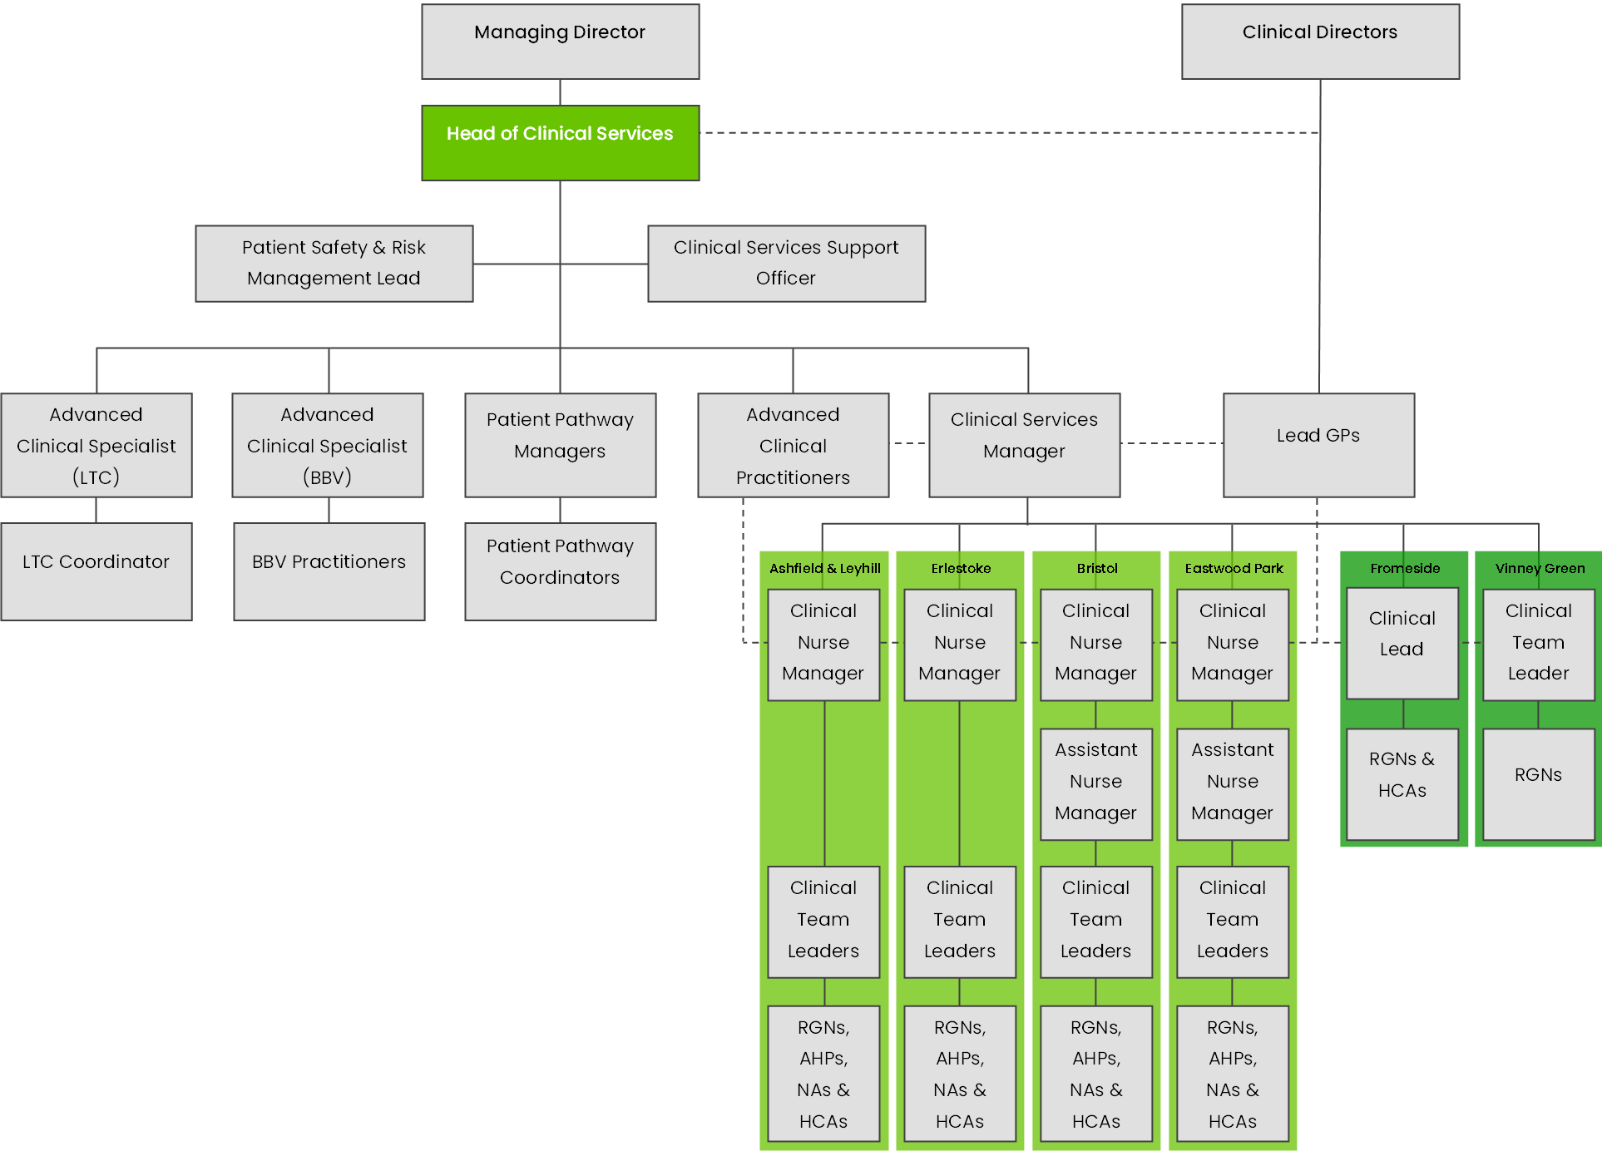  - People: concerned with all human resources, employee relations and recruitment matters, with a focus on ensuring that the Organisation is an “employer of choice”  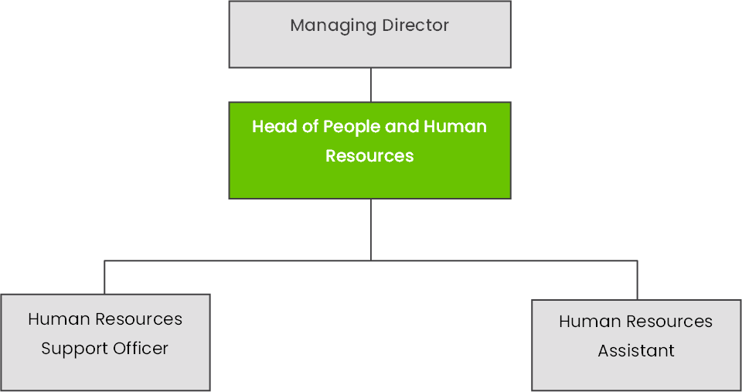  Learning and development is a function that stretches across all three pillars, and the Heads of Service work collaboratively together to ensure a shared vision and approach to the management and leadership of training across the Organisation.  The Organisation’s Board of Directors support this application - see letter from the Managing Director (executive sponsor) attached to this application
Outline of the chosen fellow, technician and/or other staff (Consider Level/grade, current role, background. Please provide details of their working week) | - HEP C Trust peer mentors- people living in prison  - Blood Borne Virus Lead Advanced Practitioner works Mon- Thurs  - Clinical Services Officer upskill regarding SIM works Mon- Friday- Admin support- keen to develop role to include an element of SIM technician in her role  - Registered and non-registered clinicians work over 7 days – delivering clinical services within the secure setting across all HSH clinical services  - Learning and Development Lead for Hanham Secure Health – nurse- works Mon-Friday  - Clinical Services Manager for Hanham Secure Health – nurse- works Monday-Friday  - Hep C Trust managers- oversee HEP C peer mentors
Details of named mentor for the Fellow with a summary of their experience in simulation, quality improvement, human factors and patient safety | N/A
Agreement that training on the iRIS platform will take place within 1 month of fellow/technician commencing post | N/A as we are not proposing a new role/fellow however, the Clinical Services Support Officer will be trained in uploading SIM to iRIS platform and also the principles of SIM when attending a 1 day training session.
Agreement that all documents, scenarios and training items used during the project will be placed on the iRIS platform | The Organisation commits to uploading all relevant documents to the iRIS platform. This will be monitored through internal review and audit to ensure full compliance. The Organisation has an in-house Digital Systems team that boasts a wealth of expertise and knowledge across the full scope of IT technologies used within the health and care sector. The team will be able to support the project team to understand and be able to competently use the iRIS platform.
Agreement that contact will take place with the HEESWSN Network Liaison at least monthly | The Organisation commits to ensuring attendance to planned meetings and has a commitment to updating HEESWSN monthly. Feedback from the HEESWSN network will form part of the standing agenda of the Organisation’s Quality Assurance Group meetings, as a way of monitoring that this contact is taking place.
Agreement that quarterly progress reports will be filed with HEESWSN via the Network Liaison | The Organisation commits to submitting quarterly progress reports to HEESWSN via the Network Liaison. This report will require internal sign-off by the Quality Assurance Group and will become a standing agenda item at the QAG meeting to ensure compliance and efficacy.
Agreement that the fellow/technician and/or project lead will attend quarterly Network Meetings and other meetings for funded projects where possible | The assigned Project Lead for the Organisation will attend and actively participate in quarterly Network Meetings and any other relevant meetings identified. The project lead will be supported by the Organisation’s robust project management policy and training, to ensure the project is managed and delivered effectively and appropriately.
Agreement that the Fellow and Project lead will complete a detailed annual/end of project report and will present the project outcomes at the HEESWSN Simulation Network Conference (or other similar event) | The Project Lead will produce and present a Project Closure Report, in accordance with the Organisation’s Project Management policy and procedure, both to the Organisation’s Quality Assurance Group and at the HEESWSN Simulation Network Conference.
Cost of project (staffing costs, other costs, total costs) | Create training content/procure training resources/standardised patients - £4500  Train the trainers - £2000  Deliver the training (trial) including room hire - £2500  Apply for CPD accreditation - £500  Travel/Subsistence/Materials - £500

END OF APPLICATION

